Tab 1

**THE DUQUESNE INCLINE**

Design Guide

**Logo** (may be subject to change)

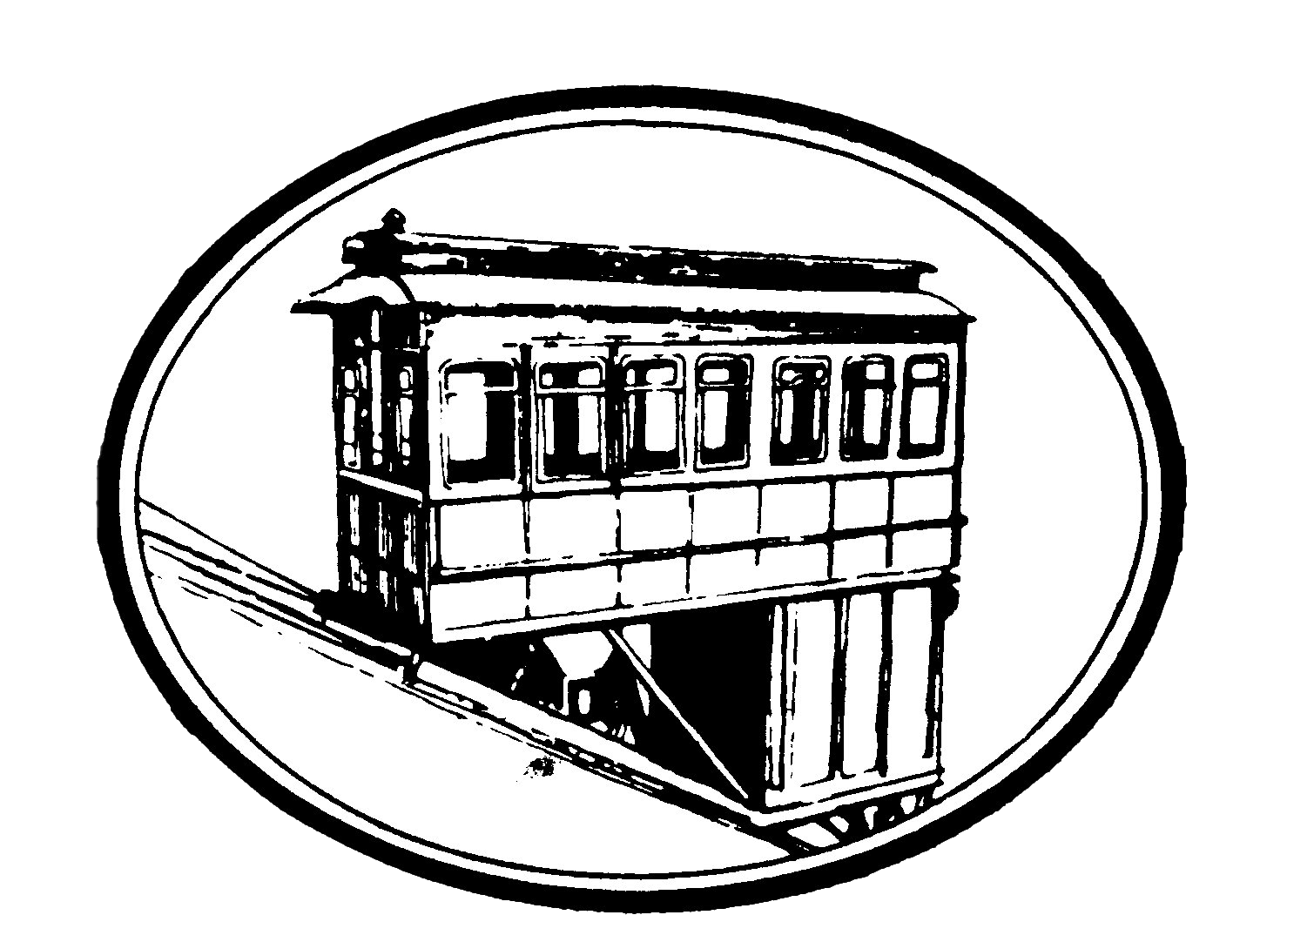

**Colors**

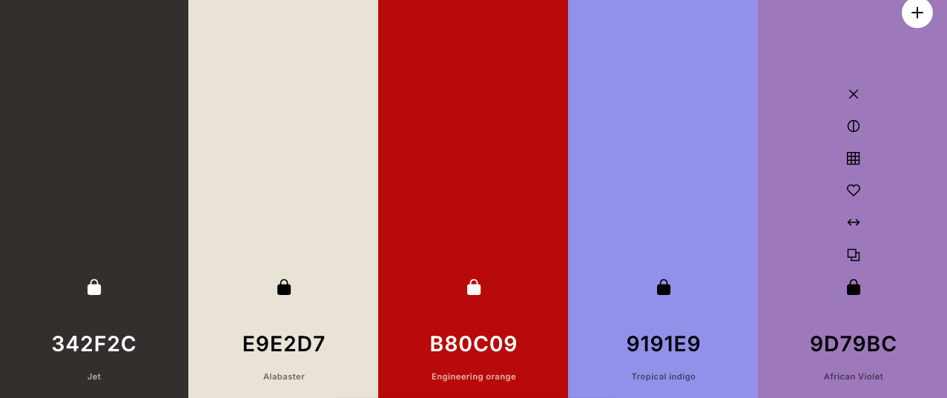

**Fonts**

Fjalla One (titles and headers)

Montserrat (smaller headers)

Inter (body copy)

**TITLE**

Subtitle

**Heading 1**

Heading 2

Heading 3

Body Text

Bulleted Point

Dev Plans

**THE DUQUESNE INCLINE**

Development Plans

**DOM Manipulation**

* Show/hide details for visitor photos
* Shuffle photo galleries for new viewers
* Hover/mouseover handler for at-a-glance card details

**API Implementation**

* Google Maps API for rendering a picture over the map directions preview

**jQuery Implementation**

* Image Carousel for Visitor photos
* FAB that expands for more quick options and contact information